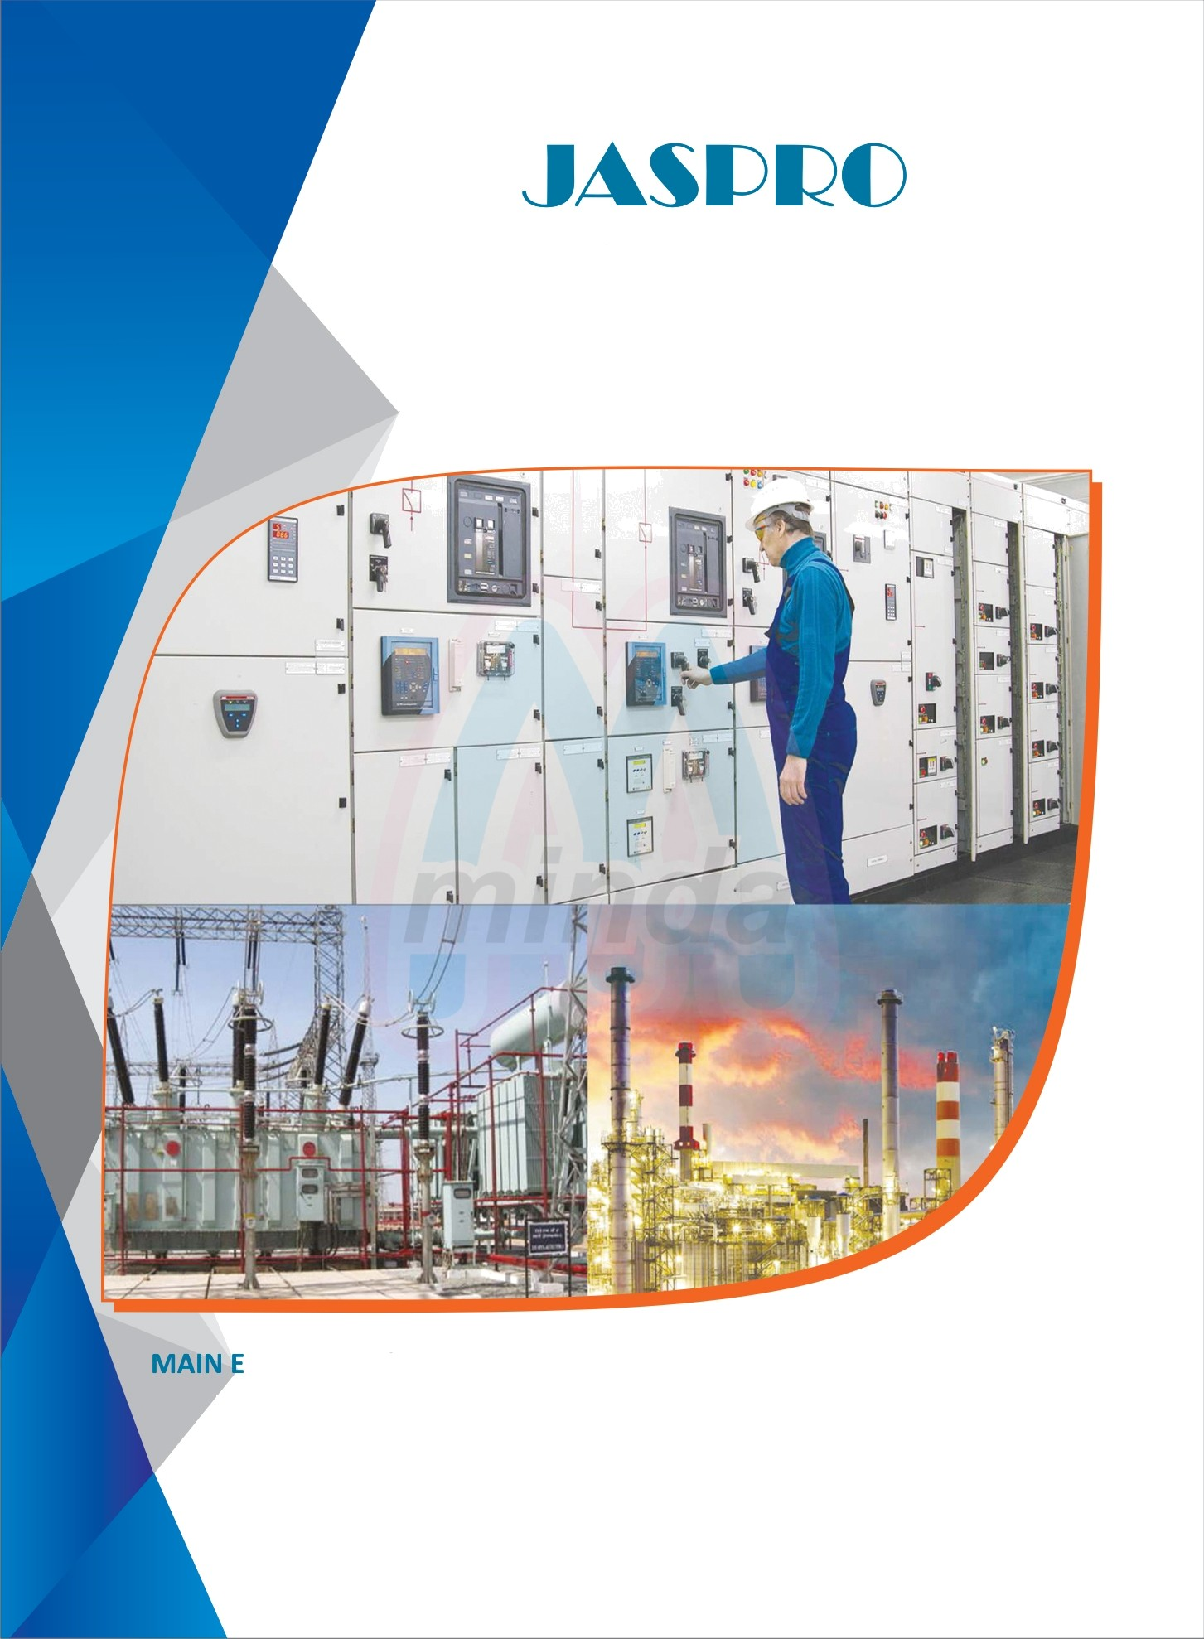

TECHNOLOGIES

ELECTRICAL & AUTOMATION BROCHURE

# LECTRICAL & AUTOMATION SERVICES OF JASPRO TECHNOLOGIES

### *”+* Electrical Design & Manufacturing • Supply, Commissioning, Operation & of LV, HV & Automation Systems Maintenance of Control Panels

* Electrical Control Panel Builders • Cable Laying, Termination, Instalation of
* Electrical & Automation Erection & Electrical Equipment
* Comissioning EMS ( Energy Monitoring • ilOT Readv Solution System) & SCADA Projects

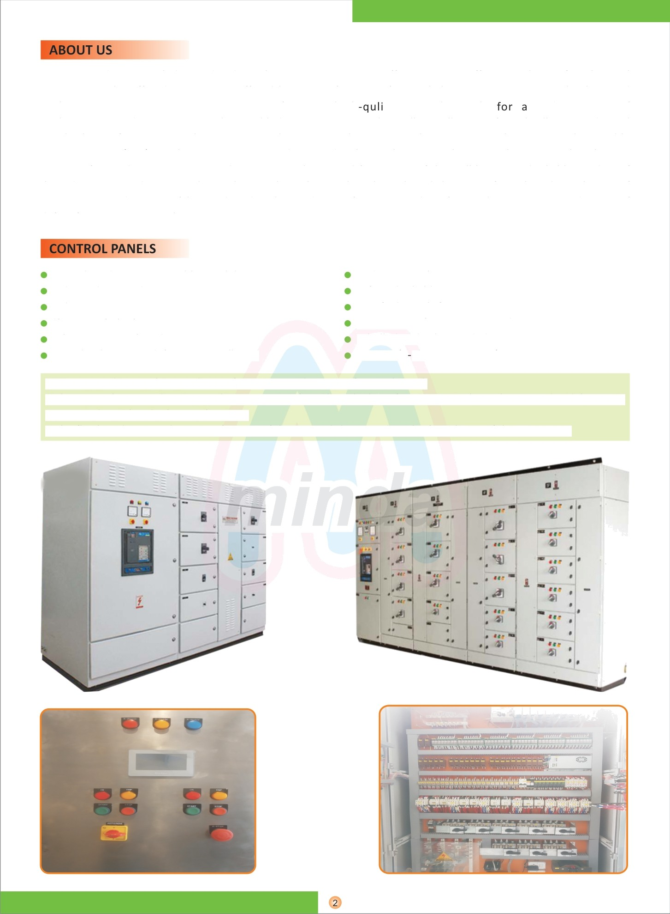Moving on deep Knowledge and industrial experience, We are offering a very effective solution for electrical engineering. The offered services are offered by our proficient professionals by using progressive technology and tools. AS **JASPRO TECHNOLOGIES** manufactures high ty control panels wide variety of applications. Our domain expertise has enabled us to come up with excellent collection of nearly all types Industrial Panel. Choose from PLC Panels, Motor control center panels, APFC panels, Power control center panels, Variable Frequency Drive(VEF) Panels, Junction Boxes and Power distribution boxes & Lighting panels. Our panel enclosures are manufactured using superior-grade raw-material procured from some of the well-known and reliable vendors of the industry, so we do can supply Stainless steel panels, Metal steel panels and Flame proof panels and Weather proof panes. Our products are fabricated under the guidance of experienced professionals to ensure production of defect-free & superior quality range.

Complete design & assembly capability Independent QC department

In-house automation team Site commissioning team Schematic & Outline drawing

Completely prewired, for easy installation

CNC construction

Safe and reliable operation Certified panels from IP42 to IP65 Components from Tier - 1 vendors Labelled and colour coded wiring 3D-CAD (E plan & Auto CAD)

¥ We engaged in supplying and manufacturing a wide range of control Panel.

* These panels are made using quality raw materials as these high performing control panels are used widely over in e many industrial and other applications.
* The flawless design and superior framing of these panels have made it the first choice of the customers.

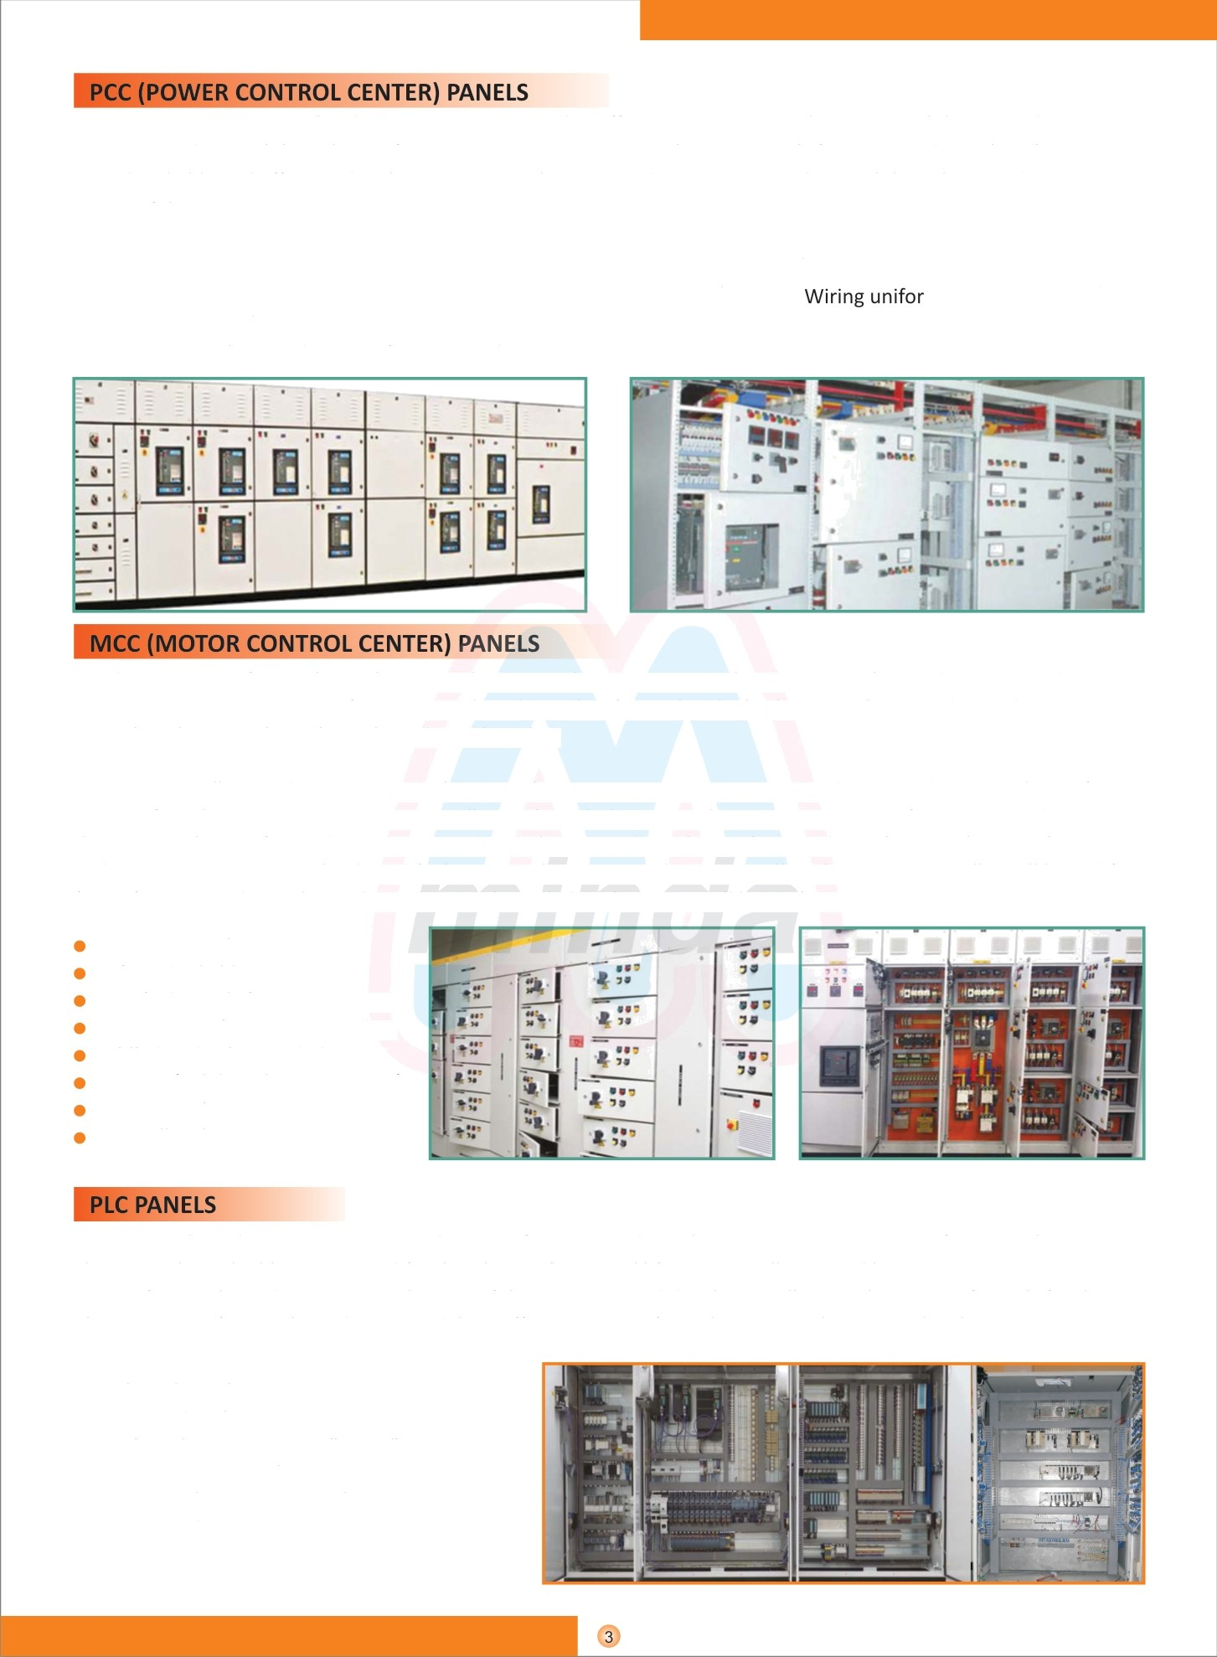Owing to our expertise in this domain, we are engaged in offering a supreme quality PCC Panel that is used to supervise and control the voltage of power systems. Power Control Center panels fo various industrial applications to provide reliable and effective distribution service. They are used to supervise and control the voltage and reactive power of the power system.

The panels will undrgo pretreatment for Decreasing, Water rinsing & De-rusting/ Phosphating, It will be painted with Powder Coated of Synthetic enamel as per the requirements. Bus Bars / Internal m cross section and **supported** by SMC / DMC bases. Earthing Bus Bars will be running all along the panel. Some of the Applications of PCCS are Dairy, Plastic industry, Refrigeration plants.

We design & manufacture low voltage switchgear panels & motor control center. Our in house design & good engineering practices in manufacturing combined together forms the ideal solution to the most demanding motor control applications throughout the industrial market.

A motor controller is a device or group of devices that serves to govern in some predetermined manner the perfor mance of an electric motor. A motor controller might include a manual or automatic means for starting and stopping the motor, selection forward or reverse rotation, selection and regulation the speed, regulation or limiting the torque, and protecting against overloads and faults. Every electric motor has a controller. The motor controller will have dif- fering features and complexity depending on the task that the motor will be performing on.

CNC construction

Safe and reliable operation Certified panels from IP42 to IP65 Components from Tier-1 vendors Lablled and colour coded wiring 3D-CAD (Solid works & Auto CAD) Easy operation

Controlling heavy starting currents

We are a reckoned organization engaged in manufacturing and supplying a compressive range of PLC Panels. These panels are highly appreciated for their longer functional life, easy installation and low maintenance.

Our professionals made optimum utilization of the resources and develop excellent quality range of panels for the Clients. Our professionals made sure to deliver effective range of panels at nominal prices to the clients.

* SS / MS / FRP / FLP Panels
* Integrated with PLC, HMI, Barriers, VFD etc
* HMI's with screen size 3.5" to 22"
* PLC's from Siemens/ Schneidar
* Desk type / Floor standing / walt mount
* Customised as per requirement

VFD Panels are designed to control the speed and torque of electric motors by varing input frequency and voltage to motors. VFD Panels are used as energy saving devices as they adjust motor speed under no load conditions or as required by the process. Such energy cost savings are especially pronounced in variable torque centrifugal fan and pump applications where there is large power reduction for a relatively small reduction in speed.

We design and manufacture a diverse range of VFD panels for variad applications (closed-loop and open-loop applications).

AHU / Chiller control

Pump / Motor / Blower speed control Reactor control

Conveyar / Crane system

Remote / Local / Bypass control options

1-400 HP (0.7557 KW-298.28 KW) drive panel

Siemens /Schneidar/ Danfoss / Yaskawa

Modular to upgrade, up to 500 KVAR Capacitors : L&T, ABB, Epcos

PF controllers : Epcos, L&T, Schneider Thyristorised or contractor based Designed with the concept at modularity. Easiness in operation, very low manual intervention.

Avoid power factor penalty.

Designed with the concept of modularity which allows upgrading of kVAR rating as and when required.

Advanced microprocessor based relay used to ensure rasl time power factor correction in the installation. Current limiting contractors are used which are specially designed for capacitor switch.

They are used to Supervise and Control the voltage and reactive power of the power system. we manufacture and supply a qual- itative range of APFC panels, thet are extensively used in various industries,. These automatic power factor control panel (APFC) are designed and developed using advanced techniques and

are capable of saving maximum power and energy. These APFC Panel are highly efficient and accurately monitor the re- active power in power systems for saving energy and can alter the system voltage as well as current.

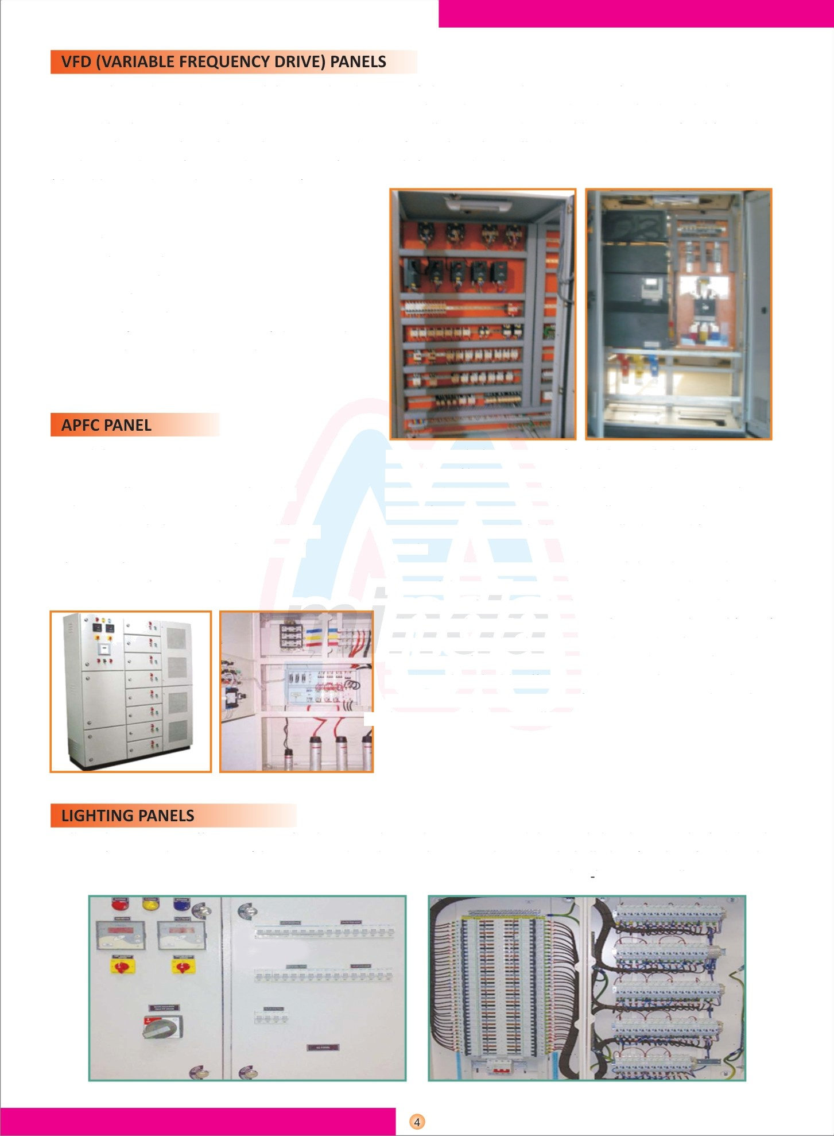

It allow the most cost effective ratings for the particular application. Two and three-pole breakers may be fitted with a range fo internal accessories (shunt trip, undervoltage release, auxiliary switch, bell alarm). When fitted to the three-pole mouting base, the TEY farnily circuit breakers can be used in unit mount/lug lug type installations.

Leveraging on our state of-infrastructure, we are able to present junction Boxes, These products are accessible for the customers in distinctive sizes and measurements, with a mean to suit their varied demands. Offered produts are easy to Install and maintenance freethat Increase their demand in the market. In order to meet varled demands of our customers, we are offering quality assured Power Distribution Boxes. These products are profoundly acknow- edged in electric wiring in household and business places. These distribution boxes are made up of quality assured parts and sophisticated technology. Our expert's team designed these distribution boxes by utilizing their skills and years of experience.

* SS316 / SS304 / MS JB with gasketed trims
* FLP Junction boxes

e Top / bottom / side cable entry

* Aluminum / copper bus option

We have emerged as one of the most prominent names in the indus- try engaged in manufacturing and supplying a wide range of Bus Duct. The ducts offered by us are widely used in automobile industry for varied purposes. Our items can be availed at reasonable rates in different grades and dimensions that suits best with the demands and requirements of our valued clients. We use high grade raw ma- terial for the manufacturing of these items that makes them durable.

Our range of products include mild steel cable tray, galvanized iron cable tray, aluminum cable tray, stainless steel cable tray.

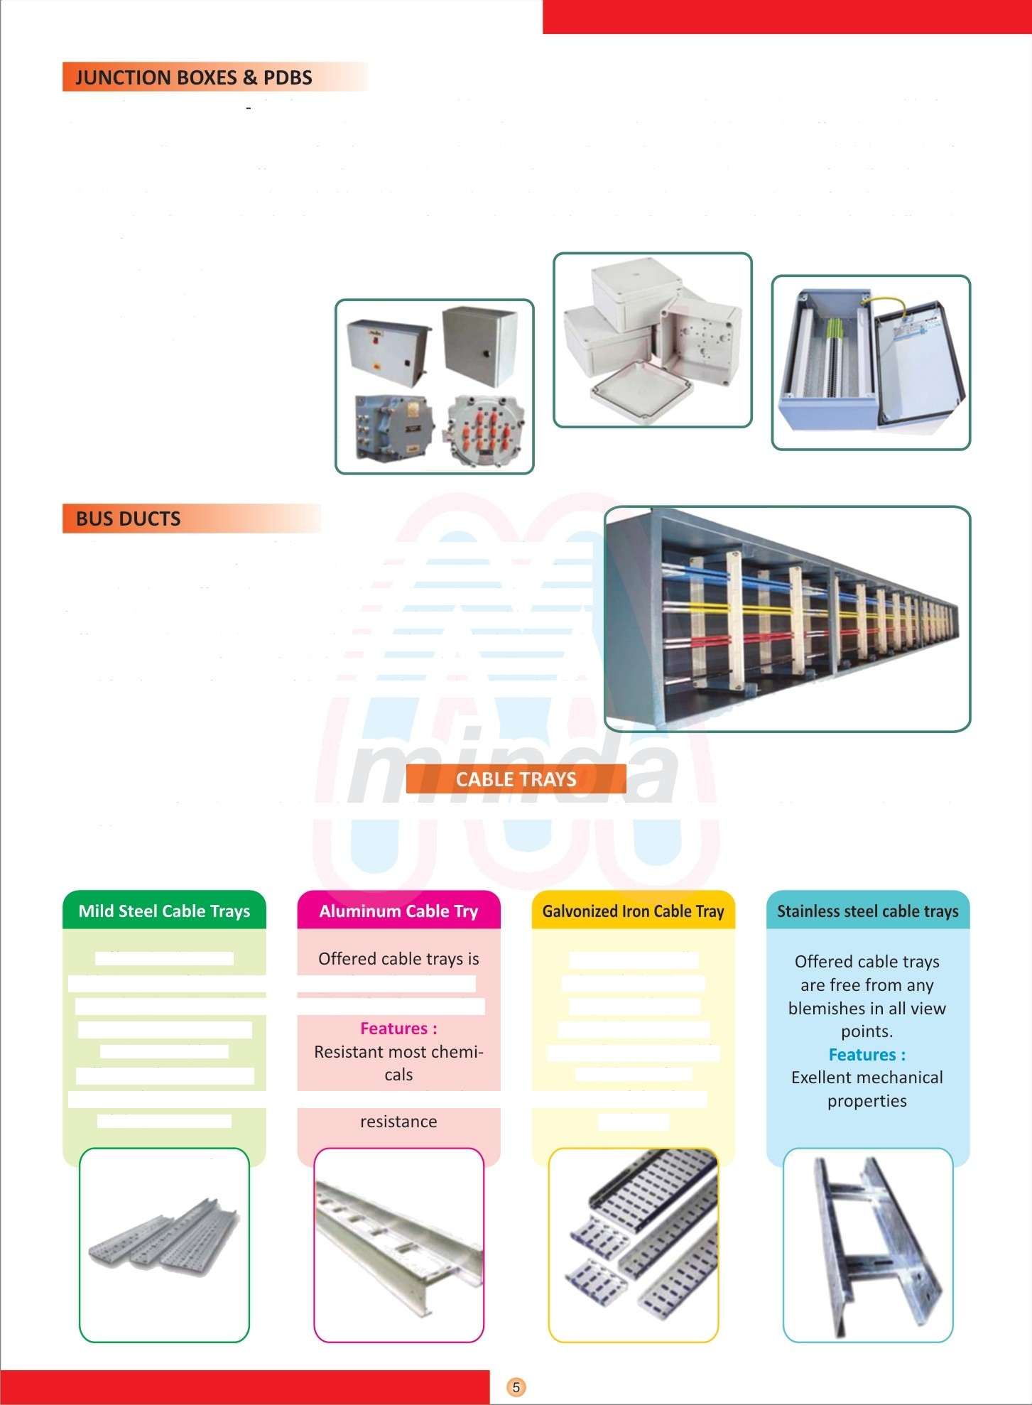

Offered mild Steel

cable trays are fabricated profoundly acknow- according to set quality edged for their quality norms and parameters

and accessible in different planes & sizes

to meet the requirement Corrosion & Wheather of the customers.

We are generally acknowledged and requested by our regarded customers due to long service life and detect free

nature of the these products.

**TESTERS **



#### Lighting Conductors

Our PROTART - 60 ESE LIGHTING CONDUCTOR & PROTART- 30 ESE

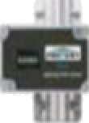LIGHTING CONDUCTOR manufactured from high quality stainless steel which makes it durable against the toughest whether condition. Whenever there is a change in electromagnetic field in the atmosphere, the ion generator inside these two conductor terminals begins to release positive ions in to atmosphre which attracts I h e I i g h I i n g e m i s s i o n s o n t o I h e E S E r o d



#### Conventional Lighting Areester

To meet the various requirements of the customers, we are involved in offering a wide assortment of Conventional Lighting Protection System.



By understanding the demands of our patrons in the best possible way, we are increasingly engrossed in offering Electrical Earthing Installation service to our clients. Delivered in tune with the standards defined by the industry, these services are enormously in demand.

|  |  |  |  |  |
| --- | --- | --- | --- | --- |
| * Chemical earthing |  |  | —- | • |
| * Conventional earthing | " |  |  |  |
| By utilizing skills of our expert professionals and creative workers, we are engaged in offering conventional earthing Services and | t. |  |  |  |
| chemical eathing service. These services are provided by our adept |  |  |  |  |
| professionals using advanced technologies. Provided service can be availed for our clients at affordable prices from us within stipulated | - |  |  | - |
| time frame. |  | , |  |  |
| We are prominent companies for offering an extensive array of |  |  |  |  |
| Earthing Electrode that are quality approved and have high compressive strength. |  |  |  |  |

## & SCADA SYSTEM

Our offered Energy Monitoring system is manufactured by utilizing optimum quality raw materials and advanced technology by our vendors’ skilled professionals. In order to ensure quality, the entire range is rigorously tested on various parameters. In tune with international standards, we provide the entire range in various specifications, as per the requirements of our clients.

Energy monitoring system [EMS] comprising of energy meter with LAN interface which can be connected with existing LAN network to collect the data instantaneously and store it in the database server. The energy meter inputs are taken from three current sensors to measure line current and three lines are connected to the energy meter to measure the line voltages. The web application

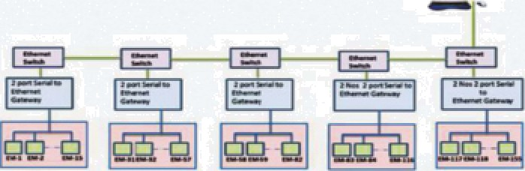

manipulates the data and produce current data and



manipulated data in the from of reports. *-*

#### Features



* Rugged construction
* Precisely designed e Rust proof

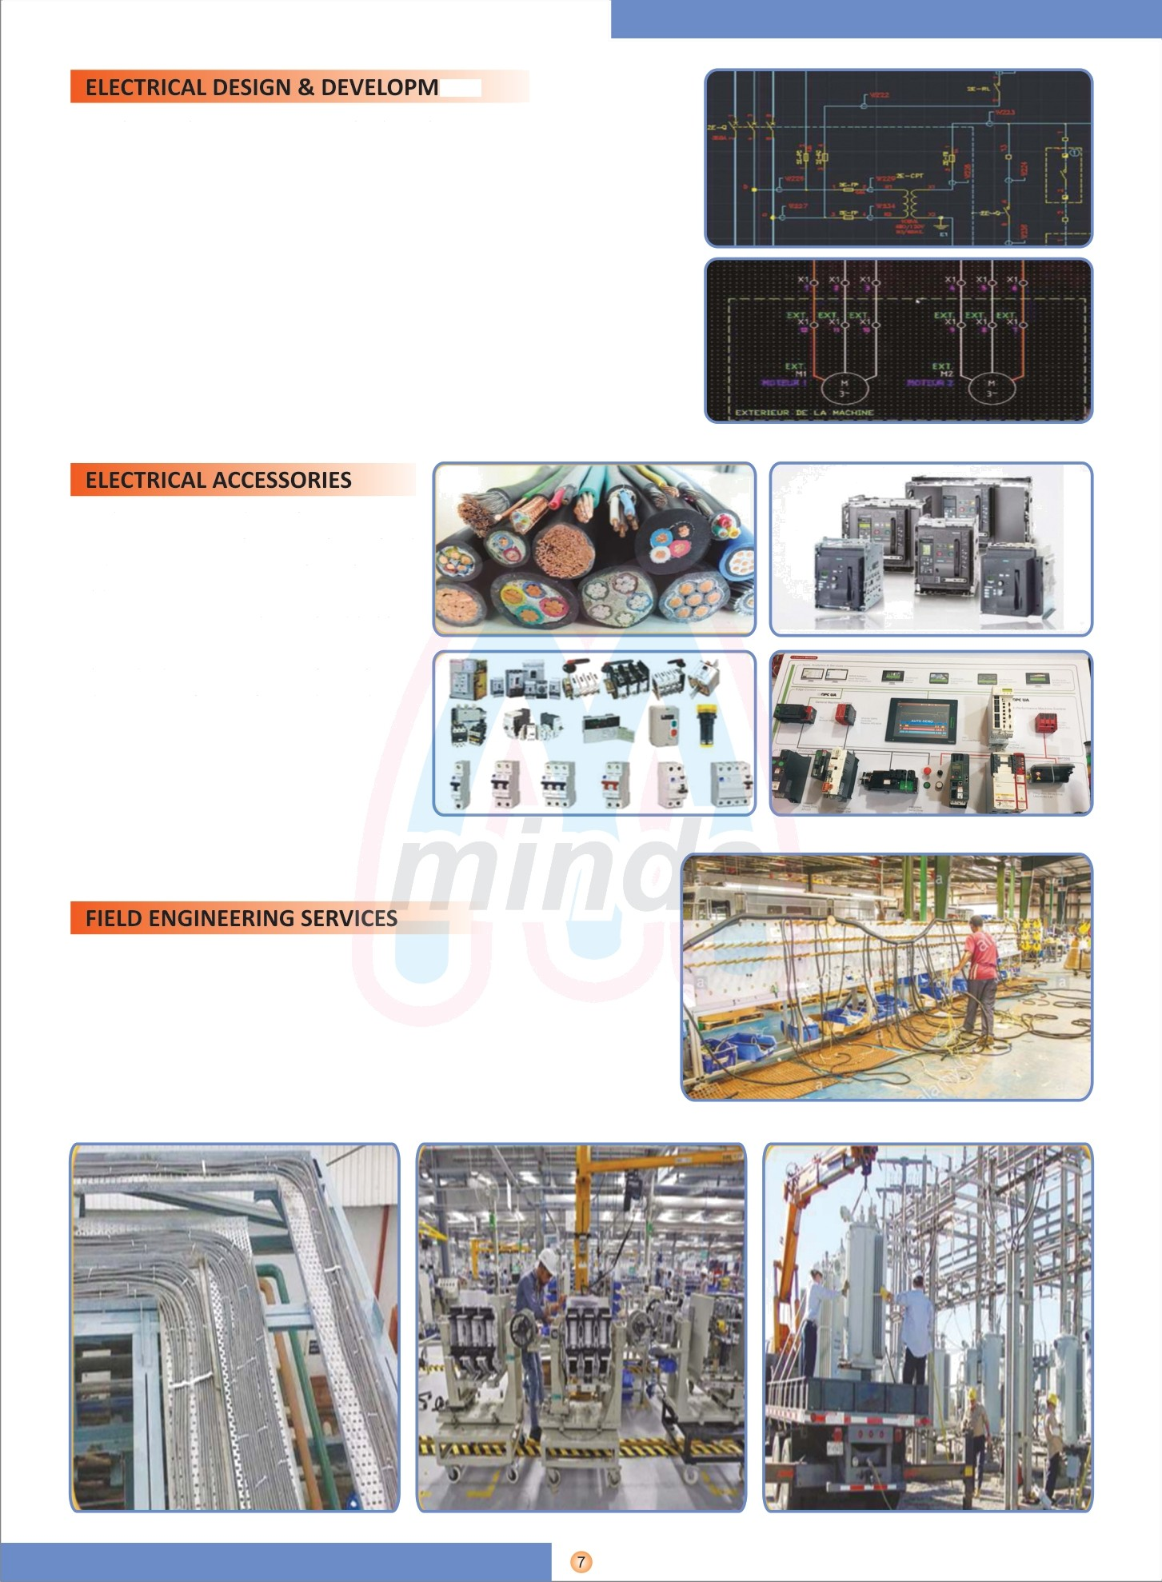ENT

* Understanding customer standards and requirement
* Design & Development of Electrical layouts
* Creation of SLD
* Electrical Engineering

e Electrical design and implementation of LV & HV Systems e Panel design and construction

e Supply, Commissioning, Operation & Maintenance of control panels

With the increasing complexity of electronic devices, computers have become imperative in electrical design, so we are designing electrical layouts by using -plan & AutoCAD.

* PLC • CABLES

e HMI e STREET LIGHT POLES o AC DRIVE o EARTH STRIPS

* SCADA • EARTH PIT MATERIAL
* RELAY o LIGHTING ACCESS.
* TRASFORMER o DB'S & JB'S
* SWITCHGEAR e PANEL BOARDS
* CABLE TRAYS o POWER CABLES
* Factory wiring

e Break down services

e Electrical maintenance

e Cable laying, Termination, Installation of electrical equipment etc.

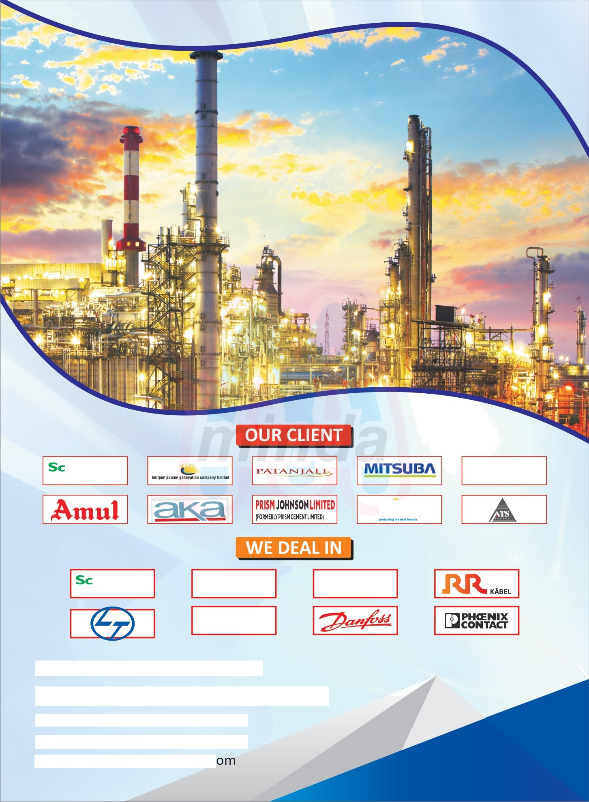

Bisferi

“TT

veritech

VASKAWA



omnon

JASPDO T€CHNOLOGI€S

# Plot No.: T—71, Budh Vihar, Phase-1, Delhi—86 O +91-9971616636, 011—27533183

n [jasprotechnologies@gmail.com](mailto:jasprotechnologies@gmail.com)

e [www.jasprotechnoIogies.c](http://www.jasprotechnoIogies.c/)